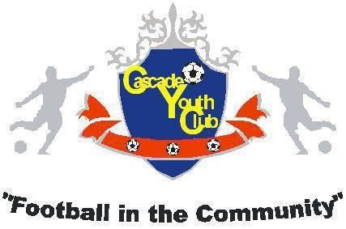

PARENTS, GUARDIANS & SPECTATORS
CODE OF CONDUCT

. fully support the Football Association of Wales Safeguarding Policy, practices and procedures and acknowledges that football parents, guardians and spectators have a fantastic opportunity to be a positive role model for the young players involved. We all have a responsibility to ensure that everyone involved in football finds it to be a fun, safe and positive experience.
Please show your support for FAW Safeguarding by signing the below declaration. By signing the code of conduct you demonstrate that you understand the following conditions.
PARENTS, GUARDIANS AND SPECTATORS ARE EXPECTED TO:
• Show exemplary behaviour by respecting and appreciating match officials, opposition players, coaches, managers and spectators.
• Deliver and collect your child punctually before and after training, matches and club events.
• Support and motivate all players, including the opposition, and encourage your child to do the same.
• Encourage your child to obey the laws of the game and teach them that they can only do their best.
• Never publicly criticise, ridicule or embarrass any children.
• Ensure your child has kit and clothing appropriate to the environment and weather conditions.
• Ensure that proper sportswear and protective kit are provided and worn.
• Disclose any medical concerns or changes in medical conditions to the Club Safeguarding Officer and the Team Manager.
• Not place unnecessary pressure on your child or push them into activities they do not want to do. Applaud effort and good play.
• Not to interfere with coach instructions and not to confuse the players by telling them what to do.
• Encourage all children not to discriminate on the grounds of religious beliefs, race, gender, social classes or lack of ability.
• Accept that striving to win is more important than winning itself.
• Respect the decisions of the match officials.
• Ensure that your child has read and understood their Code of Conduct.
• Not to post anything inappropriate, or negative on social media which may bring the game into disrepute.
• Display high standards, behave responsibly and never engage in or tolerate the use of foul, abusive, insulting or inappropriate words, behaviour or gestures.
• Get Behind the Line and not enter the field of play without prior permission from the referee.
• Make football fun.
NAME: SIGNED: DATE:

