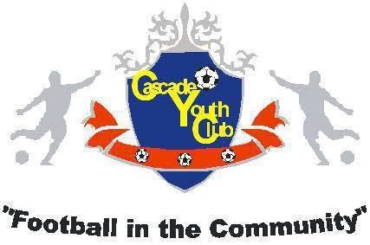

Player Code of Conduct

. fully supports the Football Association of Wales Safeguarding Policy, Practices and Procedures and is committed to safeguarding the wellbeing of its members. We all have a responsibility to ensure that everyone involved in football finds it a fun, safe and positive experience.
Please show your support for FAW Safeguarding by signing the below declaration. By signing this code of conduct you demonstrate that you understand the following conditions:
PLAYERS ARE EXPECTED TO:
• Show exemplary behaviour by respecting and listening to match officials and your coaches.
• Show respect to your opponents and shake their hands after each game.
• Accept responsibility for your own performance and behaviour.
• Treat all fellow players equally.
• Be friendly and welcoming to new players.
• Not bully or make anyone feel unhappy or sad.
• Encourage, support and co-operate with your team-mates.
• Keep yourself safe.
• Tell someone you trust about inappropriate or risky behaviour or if something makes you unhappy or uncomfortable.
• Take care of equipment owned by the club.
• Not discriminate on the grounds of religious beliefs, race, gender, social classes or lack of ability. Respect other people.
• Not take part in rough or dangerous play, bullying, or the use of bad language or inappropriate behaviour.
• Appreciate the efforts of all players.
• Not get involved in peer pressure and push others to do something they do not want to do.
• Accept that striving to win is more important than winning itself.
• Always pursue fair play – stick to the laws and the spirit of the game.
• Be positive, approachable and offer praise to promote the objectives of the club at all times.
• Display high standards, behave responsibly and never use foul, abusive, insulting or inappropriate words, behaviour or gestures.
• Respect and listen to the opinions of fellow players.
• Not to post anything nasty on social media which may bring the game into disrepute.
NAME: SIGNED: DATE:

